Uploading code to Attiny13 using Arduino Board
- https://www.instructables.com/Updated-Guide-on-How-to-Program-an-Attiny13-or-13a/
- Steps to upload code:
  - Connect the controller with arduino as shown in the figure below.
  - Set up arduino as ISP by uploading code (Arduino IDE>File>examples>11.ArduinoISP) to the board.
  - Make sure you have the attiny board (https://raw.githubusercontent.com/sleemanj/optiboot/master/dists/package_gogo_diy_attiny_index.json) added in your additional board manager urls.
  - Then download DIY attiny by James sleman from boards manager.
  - Make sure programmer is selected as “Arduino as ISP”
  - Select board as Attiny13 and upload using programmer.
- Changes:
    - Even though the chip says it attiny13A, you should select attiny13 as processor to successfully burn the bootloader.
    - direct uploading will not work, go to sketch>upload using programmer.

- If upload shows this error then there is error in connection then there is problem with the pin connections especially resent pin(reset or CS or SS). Check all the connections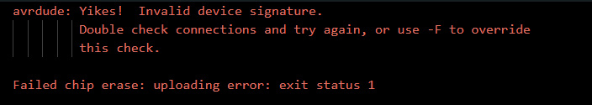

- NB: This IC does not support IRremote.h
- NB: DO NOT use the reset pin(PCINT5) as a button input or as any output since it may reset the whole IC
- NB: If you want to use any pin as analog input then do not just write "int button = 4" instead write "int button = A2" OTHERWISE IT WILL BE USED AS DIGITAL INPUT
- Upload system for attiny13 and 85 are the same
